**DSC GUI Manual**

**Stage #0 - initialization**

1. The MATLAB home directory should be set to "<something with development>\Code\DSC".
2. Run "DSCMainGUI.m" (from the directory mentioned above) 🡪 DSC GUI will be opened.
3. Click on "init" , in the upper-left part of the GUI.

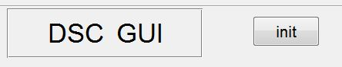

After a few seconds you should see the following message:

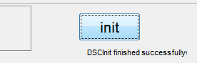

(Also in MATLAB's Command Window)

**Stage #1 – Open the data**

1. Choose the file type you wish to open – (Dicoms or Nii) and click on "Choose data folder". A dialog box will be opened. Enter the directory containing the data files (and only them), mark the first file (either dcm or nii) and press "open". The selected path will be shown in the GUI.
2. Click "Choose output folder" to choose the folder that will contain coreged data files and the maps of the results.
3. Click "Get data". MATLAB will now open the data – can take some time. At the end of the process, "Read data successfully" message will be shown both in GUI and command Window.

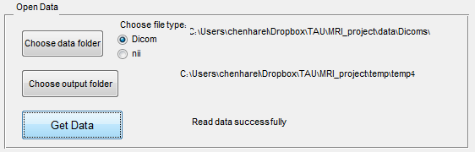

**Stage #2 – Pre-processing**

At this stage we apply a few masks on the voxels, to get only the good ones for the next stages. A few options and parameters can be set:

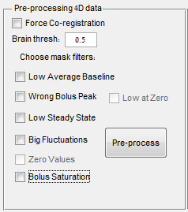

1. You can choose to force Co-registration (even if your data is already coreged). In case the data is new and fresh, Co-registration will be done anyway.
2. Set the threshold for extracting the brain voxels ( a value between 0 and 1). The default should be 0.5.
3. Choose which filters to apply for masking the bad voxels:

* **Low average baseline** - Ignore voxels which are only noise - their average baseline intensity is below a certain threshold (default threshold – 500).
* **Wrong Bolus Peak** –
* **Bolus Saturation** - Check is a voxel's peak is divided to 2 adjacent peaks (so the bolus arrival signal is in saturation) – ignore these voxels.
* **Big Fluctuations** – Ignore voxels whose time-curve is fluctuating too much (the average abs value of the gradient is bigger than a certain value (default is 1.1 times the average abs gradient over the whole 4D data).
* **Low Steady State** - Ignore voxels whose steady-state value is too low to be physical (default is when steady-state mean is lower than baseline mean)
* **Low at Zero, Zero Values** – Currently should not be in use.

1. Click Pre-process to begin calculate the mask.

You can see the process in the command window:

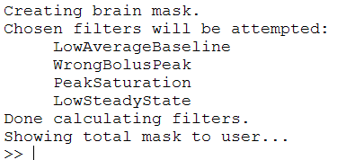

After done pre-processing (can take some time), a figure will appear, showing the final mask (in red) for all the slices.

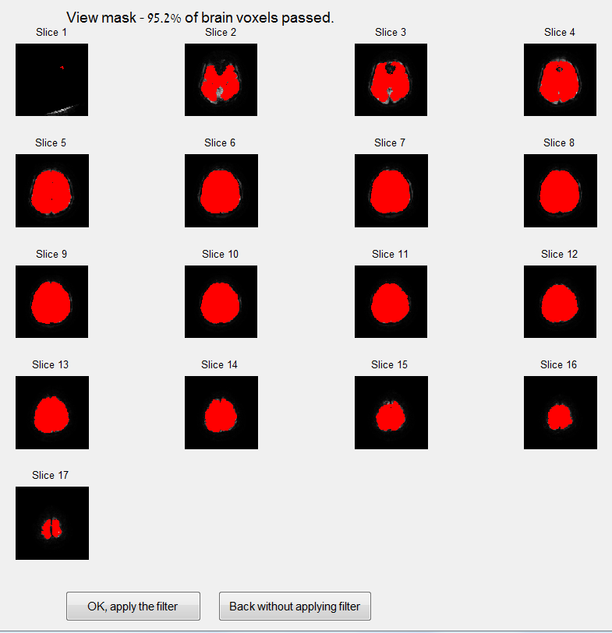

You can choose either to confirm and actually apply the filter (ignoring the non-red voxels in the next steps), or go back without applying the filter, choosing new filters to calculate.

Choosing the 2nd option (Back without applying filter) will bring you back to the main GUI, waiting for your new filter-choosing:

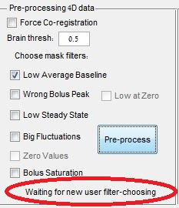

Now you can choose different filters and/or brain threshold, pre-process again, see the result mask, decide if it's good enough, and so on.

**Stage #3 – Specifying bolus properties**

After applying the mask (in the previous stage), two windows will be opened:

1. The first shows the time curves of about 20 randomly chosen voxels (the log of the intensity will be shown). The thick red vertical line indicates the bolus arrival time calculated automatically.

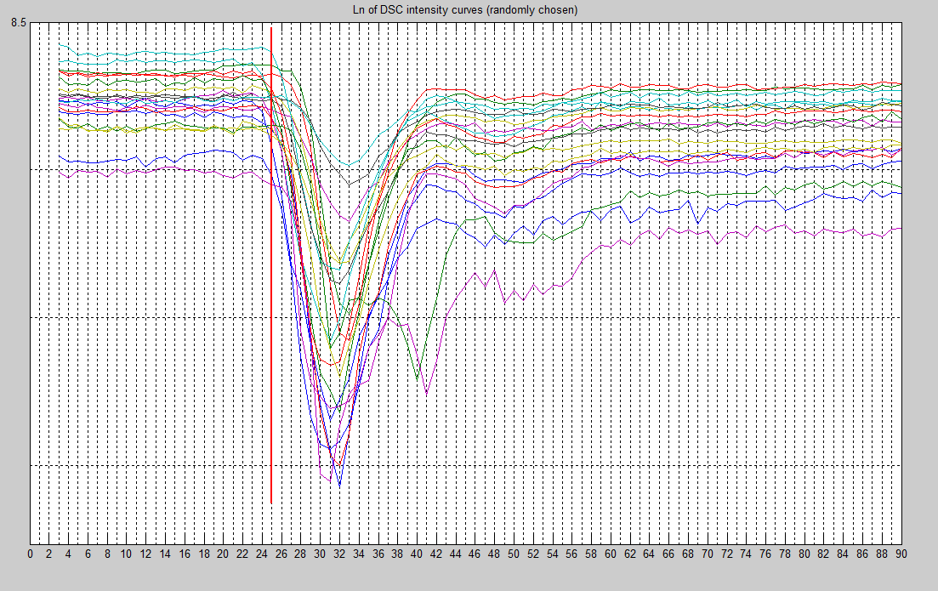

1. The 2nd window is the "bolus properties GUI", where you have to specify the time-curve parameters to be used (first and last baseline sample, and last sample of the whole curve). The intensity curves should help define these points.

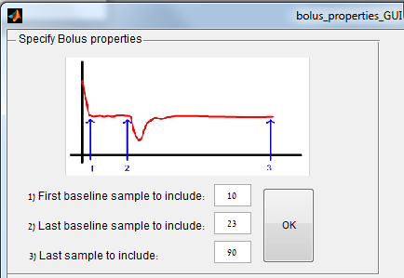

After choosing the parameters, press OK.

You'll able to update the bolus properties from the DSC GUI itself, in the upper right side.

**Stage #4 – Choosing AIF**

After defining the bolus properties in the previous stage, the "Data Window" in the center-left of DSC GUI will be filled by the MRI image signal – You can choose the which time-point and slice to show, by using the sliding-bars in the right and the bottom of the image:

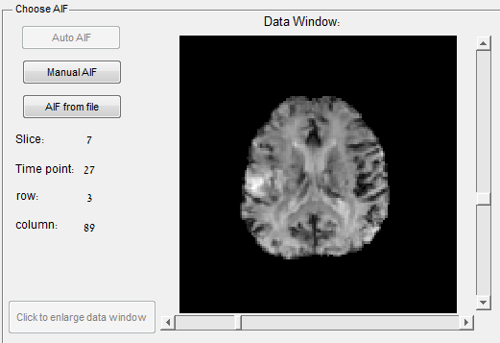

Moving the mouse over a voxel, will show its concentration curve in the window on the right:

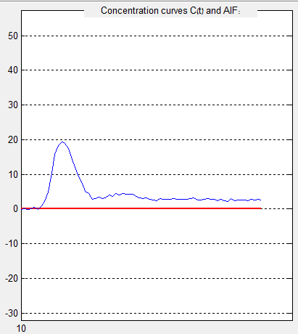

The AIF can be chosen by 3 methods: Manually by the user, automatically, or by loading an AIF text-file creating earlier by Pingwin or similar program.

Manual AIF –

* The user chooses voxels (by pressing on them with the mouse) to participate in building the AIF.
* A chosen voxel will be marked in yellow, and its coordinates will be written in the list in the right.
* Multiple voxels (in multiple slices) can be chosen.
* The final AIF will be the average of all chosen voxels.
* Deleting voxels from the list is possible.

Here is an example of building AIF from 4 different voxels (the AIF is marked in red):

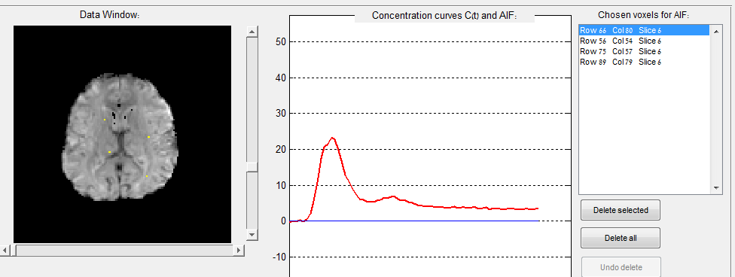

Auto AIF –

* Not available so far.

AIF from file –

Pressing that option will open a window to choose the AIF text file. The time-curve parameters chosen in stage 3 will now be updated according the data in that file.

There is no need in pressing another key to produce the AIF. It is ready while choosing the voxels manually or after loading a file.

**Stage #5 – Producing the maps**

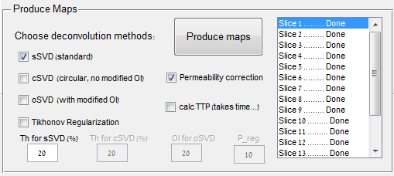

1. Choose which deconvolution methods to use (can mark more than one. each method will produce a map). Here is a list of the methods and parameters

|  |  |  |
| --- | --- | --- |
| Name | Description | Relevant parameters |
| sSVD | Standard SVD (Singular Value Decomposition) | Threshold |
| cSVD | Circular SVD, **without** minimization of oscillations. | Threshold |
| oSVD | Circular SVD, **with** minimization of oscillations. | OI (Oscillation Index) |
| Tikhonov | Tikhonov Regularization |  |

Note 1 : Maps calculation using cSVD and oSVD takes time, and using Tikhonov take a lot of time.

Note 2 : Changing a parameter becomes available only if the relevant method was chosen.

Note 3 : "P_reg" parameter is not used for now.

1. Mark the "permeability correction" if you want that the calculation of CBV will consider effects of permeability (The correction was proposed in the paper of Weisskoff 2006).
2. You can choose to calculate another parameter – TTP. (takes a lot of time).
3. Press "Produce Maps" button to start producing the maps. You can follow the process in the command window of MATLAB. A list of the methods will be shown, and also each slice being processed.

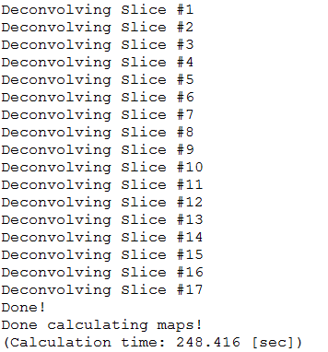

1. All maps will be saved to the output folder defined in stage #1, under the folder "results\maps_<date and time>".
2. You can open the results folder by pressing "Open Maps Folder":

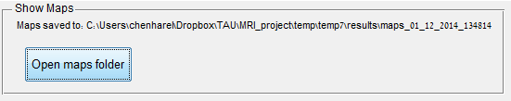

Summary of the maps created:

* Mask.mat – the voxels mask that was used.
* CBV.mat – CBV with permeability correction.
* CBV_no_corr.mat – CBV without permeability correction.
* CBV_norm.mat –CBV nomarlized in the CBV of the AIF.
* CBF_sSVD.mat,CBF_cSVD.mat,CBF_oSVD.mat – CBF, depends on the method.
* MTT_sSVD.mat,MTT_cSVD.mat,MTT_oSVD.mat – MTT depends on the method.
* TTP.mat
* K1.mat , K2.mat – parameters of the permeability correction (refer to Weisskoff 2006).